Sprint Retrospective – 24.04

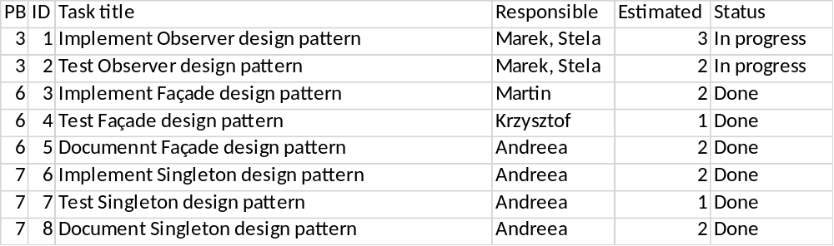

Tasks for this sprint has been planned according to the chart. The observer design pattern implementation has started, however no working result was made. Façade design pattern has been implemented and tested. Documentation of façade followed. Static class DataHandler was changed to singleton design pattern, which was fully implemented, tested and documented during the sprint.

